You can choose to submit either A1 (worth 150 points), AD1 (worth 180), or both (worth 180) for this assignment you will get a score for the assignment either 150 points base or 180 points base.
A1
Write a Java application that inputs three integers from a user and displays the sum, average, product, smallest, largest, range and median of the numbers. Please also calculate the largest divide by the smallest number provide the quotient and remainder. Use the techniques showed in chapter 2 to do this assignment. The attached files ( in CISP401V11A1.zip) could be a good base for this assignment. [Note: The calculation of the average in this exercise should result in an integer representation of the average. So if the sum of the values is 7, the average should be 2, not 2.3333….]
You can find the needed techniques in chapter 1~ 2. You can also use more advance skills to do this assignment.
This assignment comes with a CISP401V11A1.zip file. It includes two files (Calculate2.class, and Comparison.java.) The Comparison.java is base for you to start this program. So you don’t need to start from scratch.
The Calculate2.class file is an executable file. You can place Calculate2.class in a sub folder (directory). Bring up a command prompt and go to the sub directory, type “java Calculate2” in the sub directory and hit “Enter” key. You should see the program run. If you put in proper information you should get to the result in the following pictures.
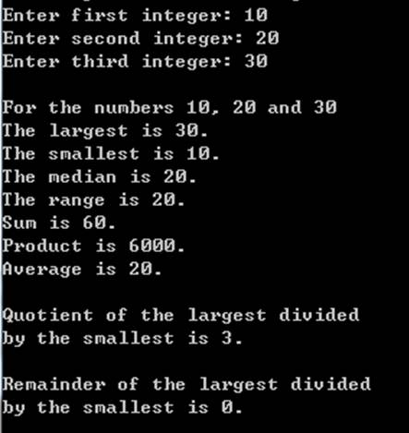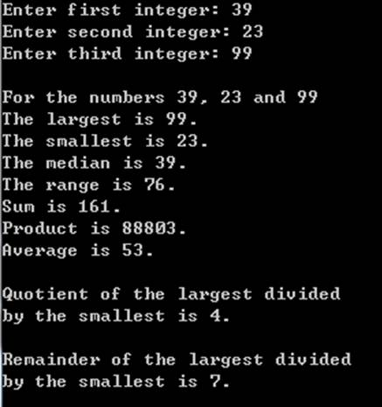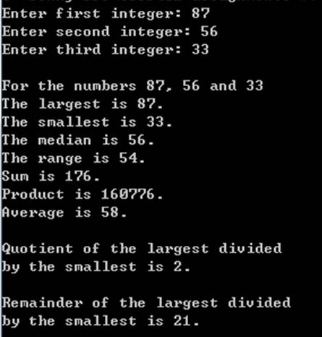
Please document the files properly and zip your .java into a proper named zip file for an assignment (refer to the assignment section of the class syllabus) and submit it to the A1 folder of the Canvas Website.
PS.
The median of a set of data is the middlemost number in the set.
The range of a set of data is the difference between the highest and lowest values in the set.

Worth 150 points

AD1
Modify class GradeBook(attached in CISP401V11AD1.zip) as follows:
- Include a second private String instance variable ( instructorName ) that represents the name of the course’s instructor.
- Provide a set method ( setInstructorName ) to change the instructor’s name. The function takes a string and does not return anything.
- Provide a get method ( getInstructorName ) to retrieve the instructor’s name. The function does not take any argument and returns a string.
- Modify the constructor to specify two parameters – one for the course name and one for the instructor’s name. The constructor will initial the two names to the private data members of the class. When run with GradeBookTest.java (included in the zip file), it will display the following message.
==GradeBook constructor is called!!==
Welcome to the grade book for
ENG CS 60 JAVA Programming!
This course is presented by: Judy Jones
== End of GradeBook constructor.==

- Modify method displayMessage such that it first outputs the welcome message and course name, then outputs “This course is presented by: “followed by the instructor’s name. When run with the test program the displayMessage function will generate the following information.
Welcome to the grade book for
CISP401 Object Oriented Programming with JAVA!
This course is presented by: Sonny Huang

You can find the needed techniques in chapter 1~ 3. You can also use more advance skills to do this assignment
This assignment comes with a CISP401V11AD1.zip file. It includes four files (GradeBook.class, GradeBook.java, GradeBookTest.class and GradeBookTest.java.) The GradeBook.java is a file for you to work on. So you don’t need to start from scratch. The GradeBookTest.java. file is a file for you to use to run with your GradeBook.java file to get to the specified result.

The GradeBookTest.class and GradeBook.class are executable files. You can place there two files in a sub folder (directory). Bring up a command prompt and go to the sub directory, type “java GradeBookTest” in the sub directory and hit “Enter” key. You should see the program run to the result in the following pictures.
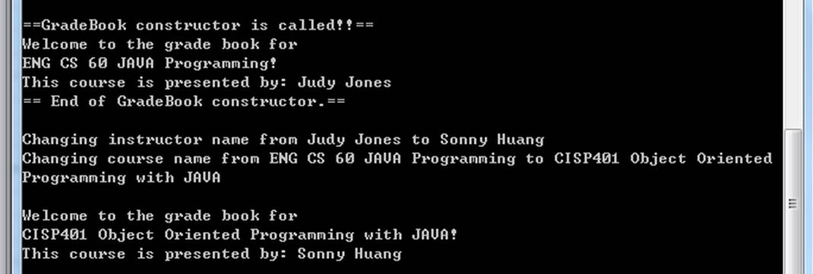
Please document the files properly and zip your .java into a proper named zip file for an advance assignment (refer to the assignment section of the class syllabus) and submit it to the A1 folder of the Canvas Website.
Worth 180 points

